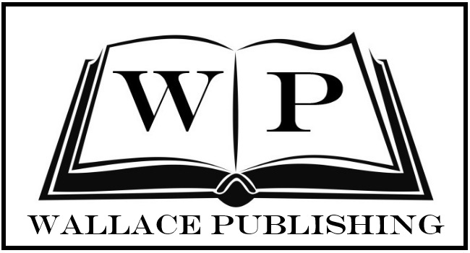
ECHOES: CATALYST
BOOK ONE OF THE ECHOES SERIES

Echoes: Catalyst is a high-octane fantasy novel that is compelling and unpredictable – this is a book that keeps you coming back for more.
Worldwide from 15th September 2017– Wallace Publishing announces the release of Echoes: Catalyst, the exciting, fast-paced and original fantasy novel that will keep everyone turning pages this fall.
M. J. Deskovic, an American born writer, releases her debut novel Echoes: Catalyst on September 15th 2017. This young adult series, laced with thought provoking moments and gripping imagery will take you on a sequence of events that is both entertaining and suspenseful.
The second installment, Echoes: Uprising is scheduled for release in the Spring of 2018, with the third installment, Echoes: Revolution following later in the year. This entire series is sure to be one that both teens and adults will enjoy.
Echoes: Catalyst is the first book in The Echoes series.
SYNOPSIS: We are all monsters, demons who have fallen from grace. Our faces drag amongst the soil as we inhale the bitterness of this world. There is no end to our sorrow as the gnashing of teeth plays on. We are the fear that fills your veins, we are the darkness, we are inescapable.
Every family has its secrets, darkness that remains buried deep within the family tree. It feeds off of your fears, temptations and those silent thoughts that plague your mind. Nothing of life grows from it, for its only footprint is destruction and decay. It echoes through time until someone, somewhere decides to take a stand.
For interviews and media appearances, book presentations and signings, contact Leesa Wallace or Emily Green at wallacepublishing@yahoo.com
####

